HANOI UNIVERSITY OF SCIENCE AND TECHNOLOGY
School of Information and communications technology

Software Requirement Specification
Version 1.2

AIMS Project
Subject: ITSS Software Development

Group 16
Nguyễn Huy Diễn – 20235910
Phạm Đức Phước – 20235988
Nguyễn Tiến Đạt – 20239715
Lê Hoàng Kiên – 20235958

Hanoi, March, 2026

Table of contents

Table of contents 1
1 Introduction 2
1.1 Objective 2
1.2 Scope 2
1.3 Glossary 2
1.4 References 4
2 Overall Description 5
2.1 Survey 5
2.2 Overall requirements 6
2.3 Business process 6
3 Detailed Requirements 11
3.1 Use case UC001 – Place Order 11
3.2 Use case UC002 – Pay Order 17
3.3 Use case UC003 – Pay Order by Credit Card 21
3.4 Use case UC004 – CUD Product 23
4 Supplementary specification 35
4.1 Functionality 35
4.2 Usability 35
4.3 Reliability 35
4.4 Performance 36
4.5 Supportability 36
4.6 Other requirements 36

Introduction

Objective
The objective of this Software Requirement Specification document is to provide a comprehensive requirement description of the AIMS system. Specifically, the document aims to provide a clear definition of functional and non-functional requirements, system behaviors, and constraints for the system.
This document acts as a communication bridge between the stakeholders involved in the development of the platform, serving as the authoritative shared agreement and understanding of the system’s capabilities and expected outcome. Intended audience of the document consists of:
- System developers: who will implement features of the system
- System designers: who will design the system architecture and components
- Testers: who will verify that the system satisfies the requirements
- Project instructors and reviewers: who will evaluate system specifications

Scope
The software product to be described in this document is called AIMS (An Internet Media Store), an e-commerce software that supports the buying and selling of physical media products. The system supports several types of physical media products including Books, Newspapers, CDs, and DVDs. Customers can browse for products, add products to a virtual shopping cart, and place orders for their purchases. Besides, the system also provides administrative features for users to manage products, orders, and users. In particular, the Product Manager can add, update, remove products, or manage stock, whereas the Administrator can manage user accounts and system roles.
The system aims to provide a convenient platform for purchasing media products while ensuring efficient product management and order processing. It also integrates payment services to support secure transaction processing.

Glossary
No | Term | Explanation | Example | Note
1 | AIMS | Stands for "An Internet Media Store", an e-commerce software that supports the buying and selling of physical media products |  | The core system described in this document
2 | Physical media | The physical products available for retail on the AIMS platform | Books, Newspapers, CDs, and DVDs | The architecture allows for future inclusion of new product categories
3 | VAT | Value Added Tax. The system strictly applies a 10% VAT for all physical media items
4 | PayPal Sandbox | A third-party service provider (external actor) integrated with AIMS to facilitate financial transactions via credit card processing |  | Used for validating transaction tokens, processing payments, and handling refunds
5 | VietQR | A third-party service provider (external actor) integrated with AIMS to process QR-based transfer payments | VietQR Test Callback API, Transaction Sync API | Generates different types of QR codes (Dynamic, Static, Semi-dynamic)  Must be unique and contain exactly 8 digits
6 | API | Application Programming Interface. Used by AIMS to communicate securely with third-party payment systems like VietQR and PayPal
7 | CUD | Stands for Create, Update, Delete. Represents the lifecycle management actions a Product manager can perform on the product catalog
8 | ISSN | An 8-digit unique number used as an identifier specifically for newspaper type products
9 | Barcode | A unique identifier for products, preventing duplication in the system and not including special characters | 202312345
10 | Token | A temporary authentication code that allows the AIMS system to access VietQR APIs. The token perform payment-related requests. |  | The token is valid for 300 seconds and must be requested again after it expires.

References
- Problem Statement for AIMS Software System: AIMS-ProblemStatement-ver3.1.1
- [TEMPLATE-EN] Software Requirements Specification (SRS) v1.2, Course Template Document
- Software Requirements Specification (SRS),Software Engineering Course Materials, Hanoi University of Science and Technology.
- PayPal Sandbox (Credit Card Payment / Refund)
https://developer.paypal.com/docs/api/payments/v2
https://developer.paypal.com/api/rest/
https://developer.paypal.com/tools/sandbox/
- VietQR (QR Code Payment) documentation
https://api.vietqr.vn/en
https://api.vietqr.vn/en/vn/overview/description-of-vietqr-api-workflow
https://doc.vietqr.vn/vietqr-doc/api-vietqr-callback/api-vietqr-host2host/integrated-document-for-payment-service-vietqr

Overall Description

Survey
AIMS is a specialized e-commerce platform designed for the retail of physical media products, including Books, Newspapers, CDs, and DVDs. The system is designed to provide a seamless, 24/7 shopping experience, that prioritizes high availability and user-friendliness for both existing and first-time users.
From a technical perspective, the software is built to handle high-traffic demands, supporting up to 1,000 concurrent users while maintaining a rapid response time of under 2 seconds during normal operations. AIMS serves as a comprehensive management and sales hub, integrating inventory control, product catalog maintenance, and secure electronic payment processing. The system's architecture is designed with extensibility in mind, allowing for the future inclusion of new product categories beyond the current physical media scope.
The following actors interact with the AIMS system to fulfill various business and operational requirements:
- Customer: The primary end-user of the system. Customers interact with the software to browse the product catalog, search for items, and manage their shopping carts. They can proceed through the checkout process and perform payments without a mandatory initial login.
- Product manager: An internal staff member responsible for the lifecycle of the store's inventory. This actor performs crucial administrative tasks such as adding new media to the stock, updating existing product details, and managing stock levels. The Product manager is also restricted by specific system constraints, such as daily deletion limits, to ensure data integrity and prevent unauthorized mass removal of items.
- Administrator: The privileged user in charge of system security and user management. The Administrator handles the creation and maintenance of user accounts, assigns functional roles, and manages access control by locking or unlocking accounts as necessary.
- Payment System (External Actor): A third-party service provider that integrates with AIMS to facilitate financial transactions. This includes PayPal Sandbox for credit card processing and VietQR for QR-based transfers. This actor is responsible for validating transaction tokens, processing payments, and handling refund requests through secure API communication.

Overall requirements
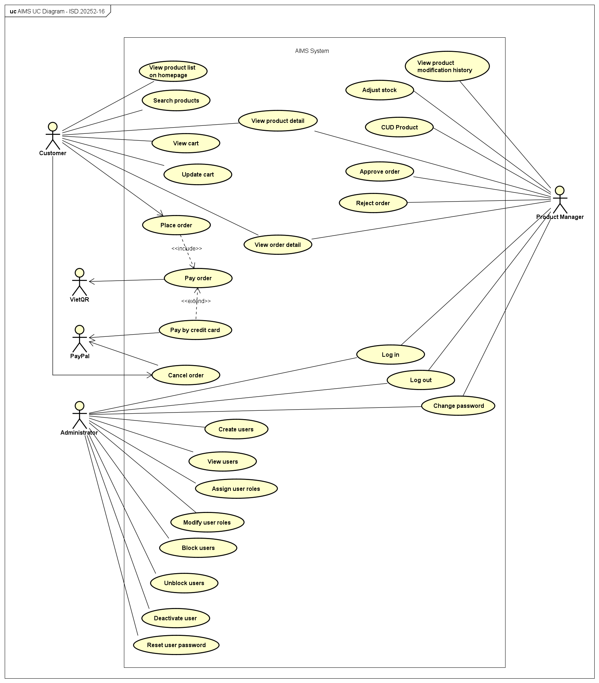
AIMS Use Case Diagram

Business process
The AIMS System supports three core business processes representing the main functionalities of the system. These processes describe how the system operates to support product buying and selling, product management, and system administration. The three primary business processes identified in the system are:
- Purchase Process: which describes how orders are created and processed from product selection to payment and order confirmation.
- Product Management Process: which describes how product information and inventory are maintained within the system.
- Administration Process: which describes how user accounts and system access are managed.
The activity diagrams below illustrate the workflows associated with these three business processes. Each diagram presents the sequence of related use cases and the interactions between the actors during the execution of these processes.
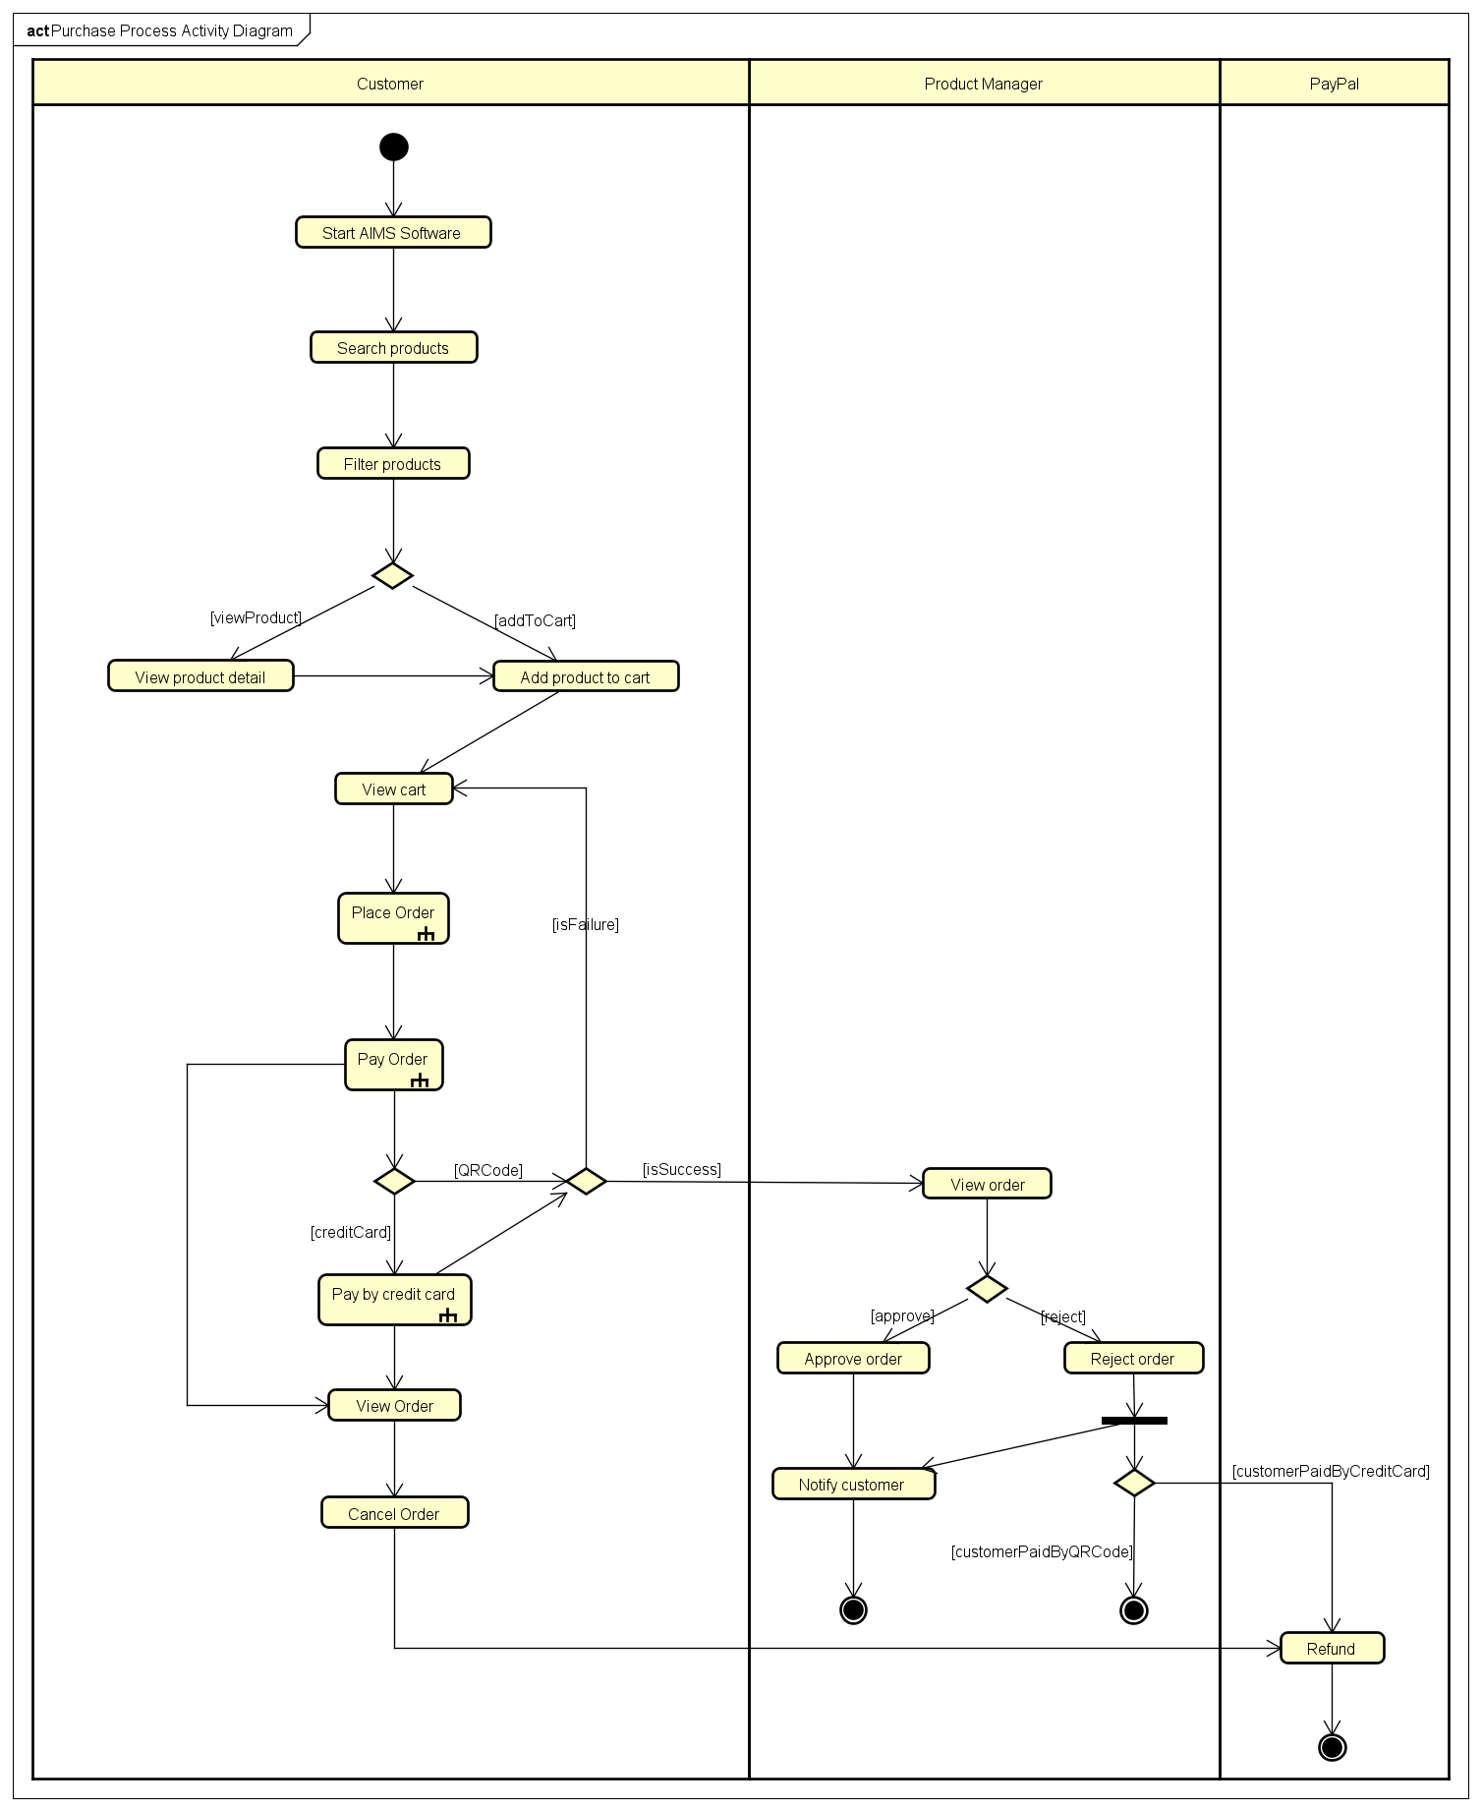
Purchase Process Activity Diagram

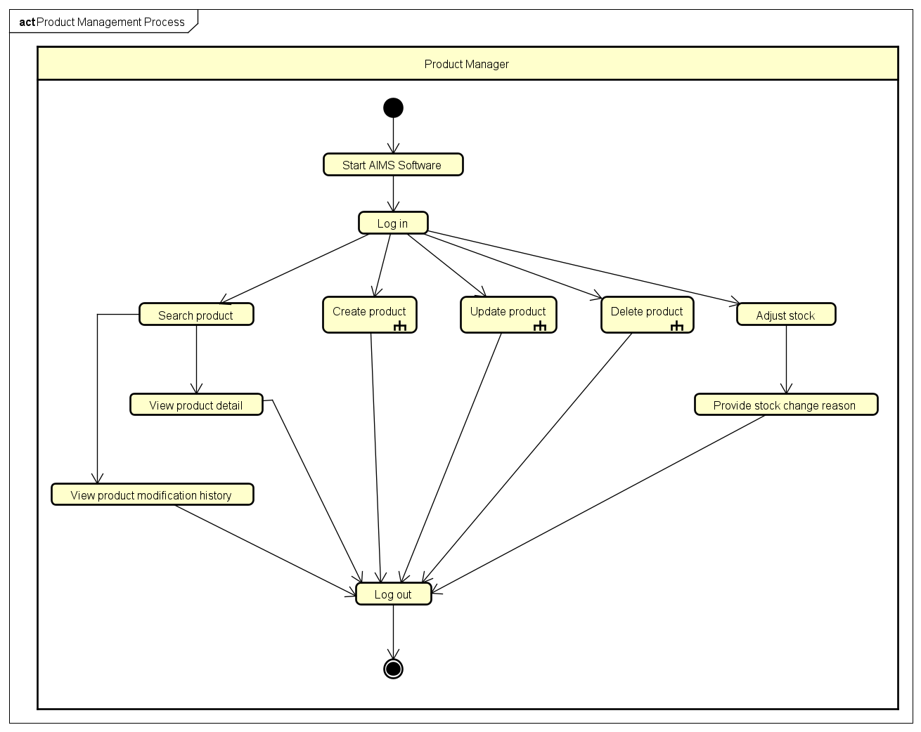Product Management Process Activity Diagram

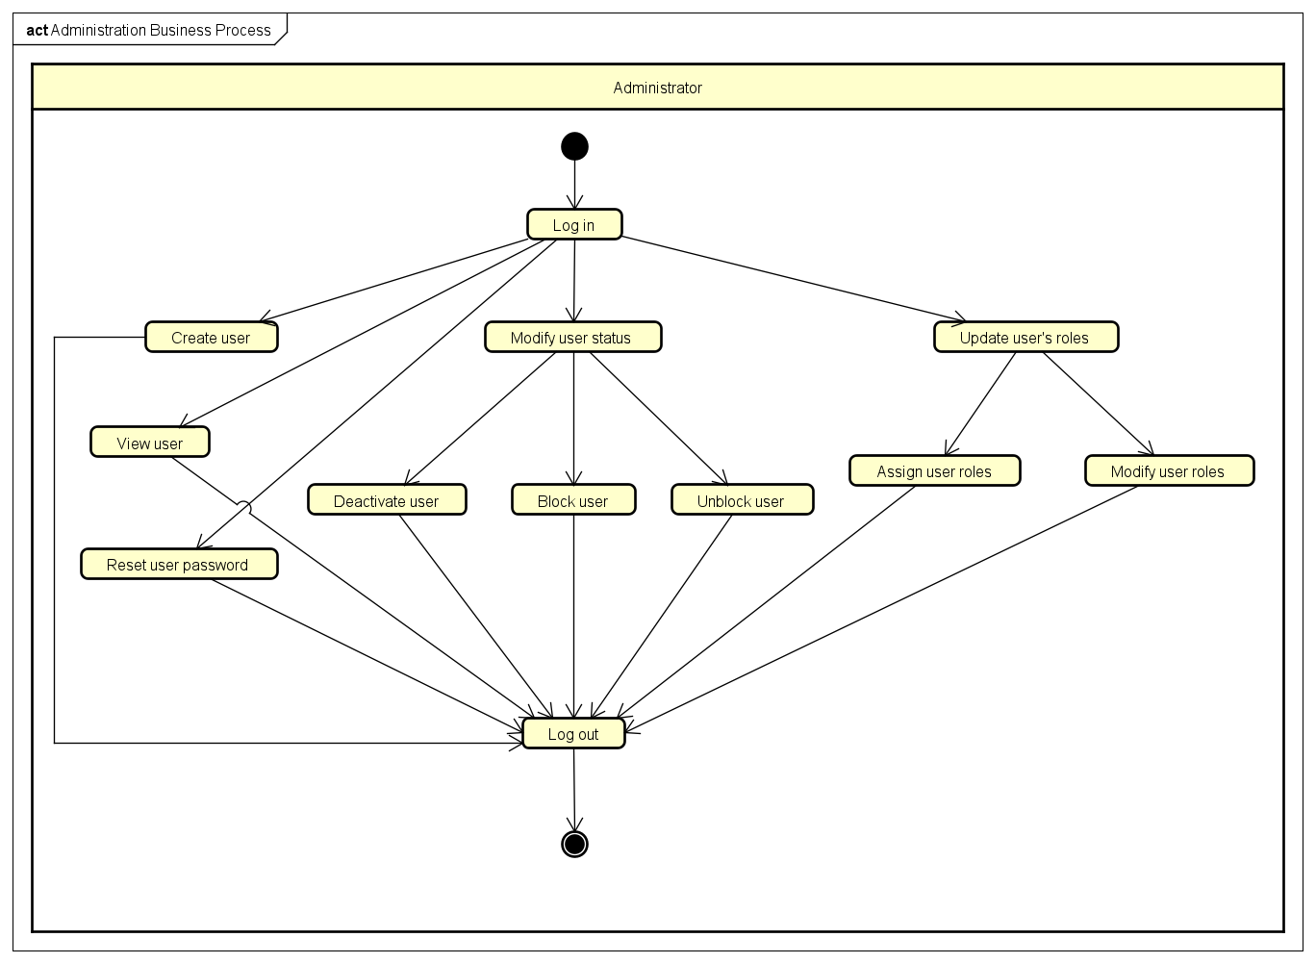Administration Process Activity Diagram

Detailed Requirements

Use case UC001 – Place Order

Use Case Place Order
- Use Case Code
UC001
- Brief Description
The use case “Place Order” describes the interaction between the customer and the AIMS Software. It is invoked when the customer wishes to place an order after the Customer has finished selecting products.
- Actor(s)
There is only 1 Actor interacting with this use case: Customer.
- Precondition(s)
The use case can only be invoked if the following condition is satisfied:
- Customer has added at least 1 product in cart.
- Basic Flow of Events
Step 1. Customer places order
Step 2. AIMS Software checks for stock availability
Step 3. AIMS Software displays the delivery form and prompts the customer to set up delivery information
Step 4. Customer enters delivery information and submits
Step 5. AIMS Software checks for missing required fields and input validity
Step 6. AIMS Software calculates and displays the delivery fee
Step 7. AIMS Software displays and temporarily saves invoice information
Step 8. Customer requests to pay for the order
Step 9. AIMS Software calls the use case “Pay Order”
Step 10. AIMS Software puts the order in pending state
Step 11. AIMS Software displays general order information and transaction information to screen
Step 12. AIMS Software sends invoice and payment transaction information to customer’s email
Step 13. AIMS Software records payment transaction information and successfully paid order
- Alternative Flows
No | Location | Condition | Action | Resume Location
1 | Step 2 | Stock is insufficient | AIMS software prompts the customer to update the cart and displays the available quantity for each affected product. | Use case ends
2 | Step 5 | Missing required fields or invalid inputs | AIMS Software prompts the customer to fill in missing fields or reenter | Step 4
3 | Step 7 | Customer requests to adjust the delivery method | AIMS Software displays the delivery form and prompts the customer to reenter | Step 4
4 | Step 7 | Customer requests to adjust product list | AIMS Software displays cart and prompts the customer to update the cart | Step 1
5 | Any step | Customer requests to go back to step N | AIMS Software redirects to step N | Step N
6 | Any step | Customer exits the software or requests to cancel order | AIMS Software cancels the ordering process | Use case ends
7 | Step 9 | Order payment is not successful | AIMS Software displays notification of failed transaction | Use case ends
Table 1-Alternative flows of events for UC Place Order
- Input data
No | Data Fields | Description | Mandatory | Valid Condition | Example
1 | Customer name | Name of the customer/receiver | Yes |  | Nguyễn Văn A
2 | Phone number | Contact number of the customer that will be used to contact the customer | Yes | - 10 digits  - Starts with 0  - May contain separators such as ‘-‘, ‘.’, or space in between digits | 0123456789  0123.456.789  0123-456-789  0123 456 789  012.34.56.789  …
3 | Province/City  (Tỉnh/Thành phố) | A province/city in Viet Nam, selectable from a list | Yes |  | Hà Nội  Nghệ An  …
4 | Ward/Commune  (Phường/Xã) | A ward/commune in that province/city, selectable from a list | Yes |  | Phường Hà Đông  Xã An Khánh  …
5 | Address | Detailed address of the customer attached to | Yes |  | 199 Chiến Thắng, Triều Khúc
6 | Delivery method | How the products should be delivered to the customer | Yes |  | Quick,  Normal (default),  …
Table 2-Input data of Delivery Information
- Output data
No | Data Fields | Description | Display Format | Example
1 | Product type + title | The type and the title of the product | [Type] [Title] | Book Data Structures & Algorithms  DVD Ice Age Collection  …
2 | Quantity | The number of the corresponding product to be purchased | Positive integer | 3
3 | Price | Price of the product | Positive integer  Includes comma for thousands | 99,000
4 | Amount | Total price for the product | Positive integer  Includes comma for thousands | 297,000
5 | Total product price | Total amount of all products | Positive integer  Includes comma for thousands | 1,423,000
6 | Total product price with VAT | Total product price + VAT | Positive integer  Includes comma for thousands | 1,585,300
7 | Delivery fee |  | Positive integer  Includes comma for thousands | 50,000
8 | Total amount | The amount to be paid | Positive integer  Includes comma for thousands | 1,635,300
Table 3-Output data of Invoice Information
No | Data Fields | Description | Display Format | Example
1 | Customer name |  |  | Nguyễn Văn A
2 | Phone number |  | 10 digits starting with 0 with ‘.’, ‘-‘, or space | 0123456789  0123.456.789  0123-456-789  0123 456 789  012.34.56.789  …
3 | Province/City  (Tỉnh/Thành phố) |  |  | Hà Nội  Nghệ An  …
4 | Ward/Commune  (Phường/Xã) |  |  | Phường Hà Đông  Xã An Khánh  …
5 | Address |  |  | 199 Chiến Thắng, Triều Khúc
6 | Delivery instructions
7 | Total amount | The amount to be paid | Positive integer  Includes comma for thousands | 1,635,300
Table 4-Output data of Order Information
No | Data Fields | Description | Display Format | Example
1 | Transaction ID
2 | Transaction Content
3 | Transaction Datetime |  | dd/mm/yyyy | 15/03/2026
Table 5-Output data of Transaction Information
- Postconditions
The use case can be considered successful if all the following conditions are satisfied:
- A new order is created in the system and its status is set to Pending.
- The system records payment transaction information and the successfully paid order
- Customer receives email containing invoice and payment transaction information
If the use case ends prematurely or is unsuccessful due to payment failure, the ordering process is reset and nothing else happens.
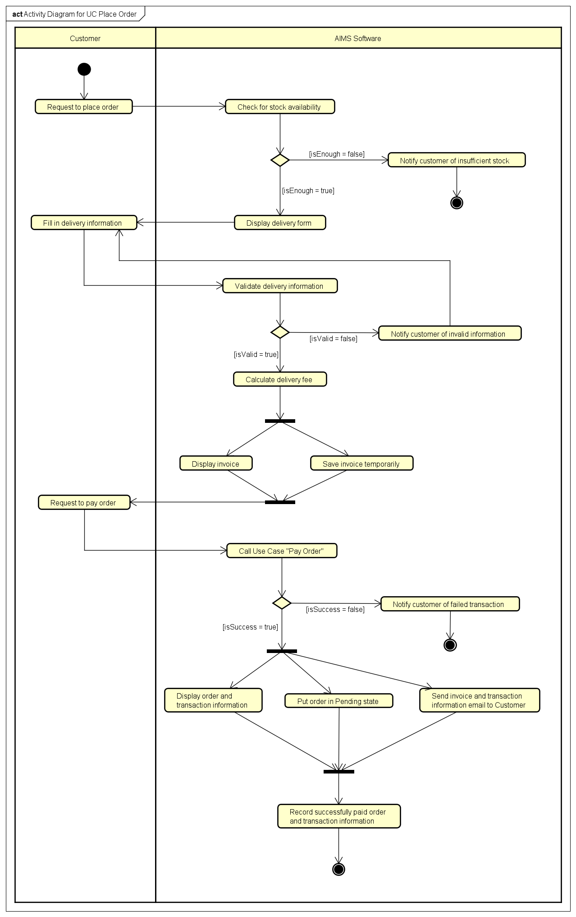
UC001 Place Order Activity Diagram

Use case UC002 – Pay Order
Use Case “Pay Order”
- Use case code
UC002
- Brief Description
This use case describes the interaction between AIMS software with the customer and VietQR when the customer wishes to pay the order
- Actors
  - Customer
  - VietQr
- Preconditions
Customer has entered valid delivery information
Aims software displayed the temporary invoice information for the order
- Basic Flow of Events
- Customer requests to pay order
- AIMS software calls the get token API from VietQR
- VietQR sends the access token to AIMS software
- AIMS software calls the API of VietQR to generate the QR code (see Table 1)
- VietQR sends the QR code for AIMS software
- AIMS software displays the generated QR code along with the invoice information on the payment screen (see Table 2)
- Customer triggers the Test Callback API
- AIMS software calls the VietQR Test Callback API to simulate a successful payment transaction (see Table 3)
- VietQR sends a payment callback to AIMS software
- AIMS software verifies the callback information
- AIMS software confirms the payment result and updates the order status

- Alternative flows
No | Location | Condition | Action | Resume location
1. | At Step 1 | If the customer choose to pay order by credit card | AIMS Software inserts the use case “Pay order by credit card” | Use case ends
2. | At Step 6 | if the customer wants to cancel the payment | AIMS Software navigates the customer back to the Invoice Screen and no order or payment made | Use case ends
3. | At Step 9 | If the payment callback indicates a failed transaction | Aims software notifies the customer that the transaction has failed | Resumes at Step 6

- Input data
Table 1-Input data of QR code generation API (VietQR system)
No | Data fields | Description | Mandatory | Valid condition | Example
 | BankCode | Code of the receiving bank account | Yes | Valid bank code supported by VietQR | MB
 | BankAccount | Bank account number for the transfer | Yes | Valid bank account number | 113000045678
 | UserBankName | Name of the bank account holder | Yes | Must not contain Vietnamese accents | Nguyen Dang Quang
 | Content | Payment transfer content | Yes | Maximum 19 characters, no special characters | ORDER112
 | qrType | Type of VietQR code to generate | Yes | Dynamic QR = 0, Static QR = 1, Semi-dynamic QR = 3 | 0
 | Amount | Total money of the corresponding media | No | - qrType = 0 or qrType = 3 required  - Positive integer | 175000
 | OrderId | Unique identifier of the order | No | ≤ 13 characters | ORDER001
Table 2-Input data of VietQR Test Callback API (VietQR system)
No | Data fields | Description | Mandatory | Valid condition | Example
1. | BankAccount | Bank account number for the transfer | Yes | Valid bank account number | 113000045678
2. | Content | Payment transfer content | Yes |  | ORDER112
3. | Amount | Total money of the corresponding media | Yes | - Positive integer | 300000
4. | TransType | Payment transfer content | Yes | C = credit transaction, D = debit transaction | C
5. | BankCode | Code of the receiving bank account | Yes | Valid bank code supported by VietQR | MB
- Output data
Table 3-Output data of QR code along with the invoice information (Aims software)
No | Data fields | Description | Display format | Example
 | Bank Name | The name of the receiving bank |  | VietinBank
 | Bank Account | Bank account number for the transfer |  | 1130 0004 5678
 | UserBankName | Name of the bank account holder |  | Nguyen Dang Quang
 | Amount | Total money of the corresponding media | - Comma for thousands separator  - Positive integer | 150,000 VND
 | QR Code | QR image generated from the string | QR Image

- Postconditions
- After a successful payment, the order is stored in the Aims Software with the status “Pending Processing”
- Aims software will display general information of the order and transaction information, and then send invoice with payment transaction information to the customer's email.

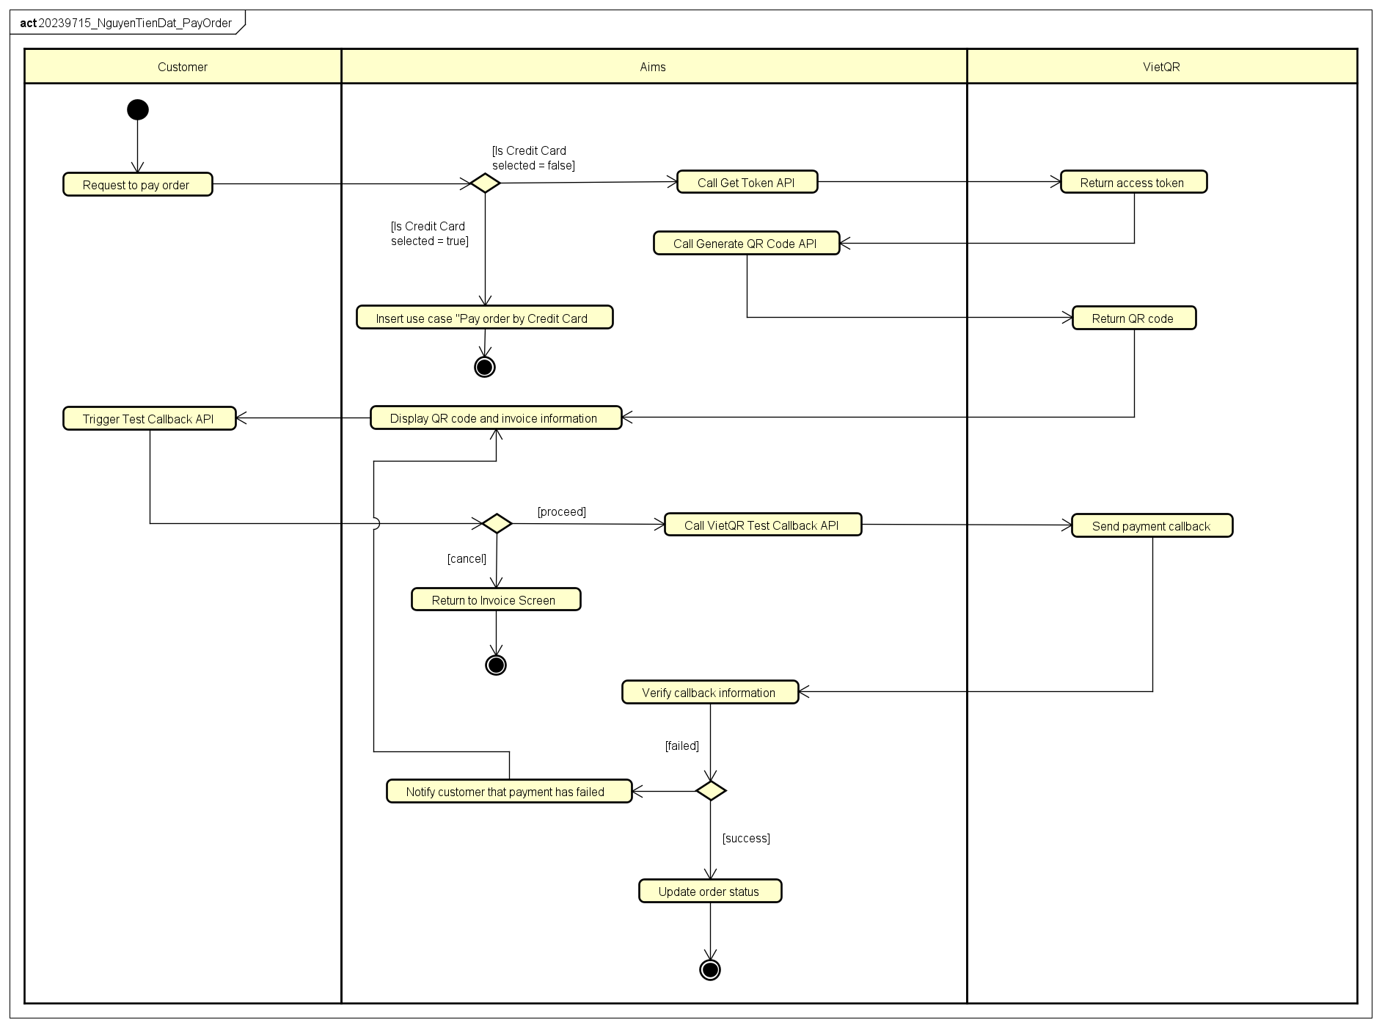
UC002 Pay Order Activity Diagram

Use case UC003 – Pay Order by Credit Card
Use Case Pay Order by Credit Card
- Use case code
UC003
- Brief Description
The use case “Pay Order by Credit Card” describes the interaction between the Customer, the AIMS Software, and the PayPal payment gateway. It is invoked when the Customer chooses to pay for their order using a credit card rather than the default QR code method.
- Actors
There are two actors:
Primary Actor: Customer.
Secondary Actor: PayPal (Payment Gateway).
- Preconditions
+ The use case “Place Order” has been initiated.
+ The Customer has confirmed the invoice information.
+ The total amount, including VAT and shipping fees, has been calculated.
+ The Customer has selected "Credit Card" as the payment method.
- Basic Flow of Events
- AIMS Software displays the credit card information entry form.
- Customer enters credit card details (Card Number, Holder Name, Expiration Date, and CVV) and submits.
- AIMS Software validates the format of the entered data.
- AIMS Software sends a payment request with the transaction amount to the PayPal system.
- PayPal authenticates the card and checks for sufficient balance.
- PayPal processes the transaction and returns a "Successful" status and transaction ID to AIMS Software.
- AIMS Software records the payment transaction details.
- AIMS Software displays general information of the order (customer name, phone number, shipping address, province, total amount) and transaction information (transaction ID, transaction content and transaction datetime).
- AIMS Software sends invoice and payment transaction information to the customer's email.

- Alternative flows
Table 01 - Alternative flows of events for UC Pay Order by Credit Card
No | Location | Condition | Action | Resume location
1 | Step 3 | Invalid card data format | AIMS Software notifies the user of the specific error | Resumes at Step 1
2 | Step 5 | Authentication failed or Insufficient balance | AIMS Software displays a Failed message. | Use case ends
3 | Step 4 | Connection timeout with PayPal | AIMS Software notifies that the payment gateway is unavailable. | Use case ends
4 | Step 1 | Customer cancels payment | AIMS Software returns to the payment method selection screen. | Use case ends
- Input data
Table 02 - Input data of Credit Card
No | Data fields | Description | Mandatory | Valid condition | Example
1 | Card Number | The 16-digit credit card number | Yes | Must be numeric | 2560 4508 3456 6789
2 | Cardholder Name | Name as it appears on the card | Yes | Alphabetic characters only | PHAM DUC PHUOC
3 | Expiration Date | The card's expiry date | Yes | MM/YY format and must be in the future | 03/30
4 | CVV/CVC | Security code on the back | Yes | Exactly 3 digits | 222
- Output data
Table 03 - Output data of Transaction Result
No | Data fields | Description |  | Display format | Example
1 | Transaction ID | Unique ID provided by PayPal |  | Alphanumeric | PDP-12345678
2 | Amount | Final charged amount |  | Integer with comma separator | 3,636,366 VNĐ
3 | Date | Date and time of transaction |  | dd/mm/yyyy hh:mm | 03/06/2025 03:06
4 | Status | Outcome of the process |  | Text | Successful
5 | Transaction Content | Purpose of transaction | Text |  | Payment for order #98765

- Postconditions
+ Success: A new transaction record is saved, the order status is updated to " Pending processing state," and the cart is emptied.
+ Failure: No payment is recorded, and the order remains unpaid.

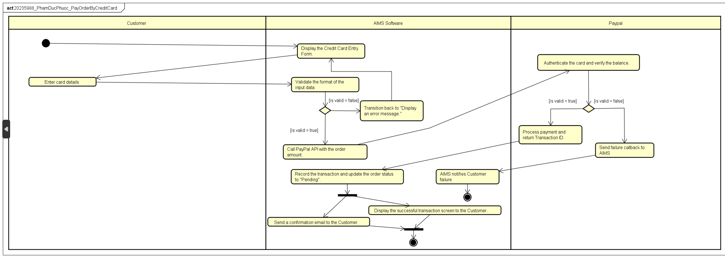 UC003 Pay Order by Credit Card Activity Diagram

Use case UC004 – CUD Product
Use Case “CUD Product”
- Use case code
UC004
- Brief Description
This use case allows the Product manager to maintain the product catalog. It includes adding new physical media (Books, CDs, DVDs, Newspapers), updating existing product information, and removing products from the system according to stock and quantity constraints.

- Actors
Product manager
- Preconditions
The use case can only be invoked if the following conditions are satisfied:
- Product manager is logged into the AIMS software.
- The software is displaying the product management dashboard.
- Basic Flow of Events
  - Basic flow: Create product
Step 1: Product manager selects the "Add product" option.
Step 2: AIMS software displays the product entry form (Title, Category, Price, Weight, etc.).
Step 3: Product manager fills in the form and selects the product type (Book, CD, DVD, or Newspaper). (see Table 2)
Step 4: AIMS software adds specific fields for that type. (see Table 3, 4, 5, 6)
Step 5: Product manager enters all required information and clicks "Save".
Step 6: AIMS software validates the data and uniqueness of the barcode.
Step 7: AIMS software saves the new product and displays a success message.

  - Basic flow: Update product
Step 1: Product manager selects a product from the list and clicks "Edit".
Step 2: AIMS software retrieves and displays the current information of the product.
(see Table 7 and Table 9, 10, 11, 12, 13)
Step 3: Product manager modifies the desired fields.
Step 4: Product manager clicks "Update".
Step 5: AIMS software validates the changes.
Step 6: AIMS software saves updated information and notifies the Product manager.

  - Basic flow: Delete product
Step 1: Product manager selects one or more products (up to 10) from the list.
(see Table 8)
Step 2: Product manager clicks "Delete".
Step 3: AIMS software checks the stock level for each selected product.
Step 4: AIMS software deletes selected products.
Step 5: AIMS software displays a summary of the action (number of products deleted).

- Alternative flows
No | Location | Condition | Action | Resume location
1 | At step 6 (Create) or step 5 (Update) | AIMS software detects invalid formats (e.g., negative price, empty title). | Action 1: AIMS software highlights the error fields.  Action 2: The Product manager corrects the data and re-submits. | At step 7 (Create) or step 6 (Update)
2 | At step 1 (Delete) | Product manager selects more than 10 products. | AIMS software prevents the action and displays failure message. | At step 1(Delete)
3 | At step 2 (Delete) | Total deleted products of the day have already been 20. | AIMS software prompts a failure message of exceeding daily quota (20) | Use case ends
4 | At step 2 (Delete) | Total deleted products of the day will exceed 20 after the process | AIMS software prevents the action and require to reduce the product to be deleted | At step 1 (Delete)
5 | At step 3 (Delete) | Exist products in the deletion list that have stock > 0 | AIMS software deactivates those products and includes number of deactivated products in the summary | At step 5 (Delete)
6 | At any step | Product manager wants to cancel the operation | AIMS software return to manager dashboard | Use case ends

Table 1: Alternative flows of events for UC CUD product
- Input data
No | Data fields | Description | Mandatory | Valid condition
1 | Barcode |  | Yes | must be unique, not including special characters
2 | Title |  | Yes
3 | Category | Choose from a list | Yes
4 | Original value |  | Yes | must be positive
5 | Current value |  | Yes | must be positive
6 | Description |  | No
7 | Height |  | Yes | must be positive
8 | Width |  | Yes | must be positive
9 | Length |  | Yes | must be positive
10 | Weight |  | Yes | must be positive
Table 2: General data for UC Create product

No | Data fields | Description | Mandatory | Valid condition
1 | Author |  | Yes
2 | Cover type | Choose from a list | Yes
3 | Publisher |  | Yes
4 | Publish date |  | Yes
5 | Number of pages |  | No | integer number, must be positive
6 | Language |  | No
7 | Genre |  | No
Table 3: Data for book type products creation

No | Data fields | Description | Mandatory | Valid condition
1 | Chief editor |  | Yes
2 | Publisher |  | Yes
3 | Publish date |  | Yes
4 | Issue number |  | No
5 | Publication frequency |  | No
6 | Language |  | No
7 | ISSN | an 8-digit number | No | must be unique, contains 8 digits
8 | Language |  | No
9 | Section |  | No

Table 4: Data for newspapers type products creation

No | Data fields | Description | Mandatory | Valid condition
1 | Artist |  | Yes
2 | Record labels |  | Yes
3 | Tracks list |  | Yes
4 | Genre |  | Yes
5 | Release date |  | No

Table 5: Data for CD type products creation

No | Data fields | Description | Mandatory | Valid condition
1 | Disc type | Choose from a list | Yes
2 | Director |  | Yes
3 | Runtime |  | Yes | integer number, must be positive
4 | Studio |  | Yes
5 | Language |  | Yes
6 | Subtitles |  | Yes
7 | Release date |  | No
8 | Genre |  | No

Table 6: Data for DVD type products creation

No | Data fields | Description | Mandatory | Valid condition
1 | Barcode/ID |  | Yes | unique
2 | Data field to be modified (similar to data meant for creating product) |  | Yes | depend on the data to be modified

Table 7: Data for UC Update product

No | Data fields | Description | Mandatory | Valid condition
1 | List of product barcode/ID that will be deleted |  | Yes

Table 8: Data for UC Delete product

- Output data
No | Data fields | Description | Display format | Example
1 | Barcode | ID of the product |  | 202312345
2 | Title | Title of a media product |  | DVD Phim Vượt ngục
3 | Category | Type of product |  | DVD
4 | Original value | Original price of the corresponding media product | Comma for thousands separator  Positive integer  Right alignment | 123,000
5 | Current value | Current price of the corresponding media product | Comma for thousands separator  Positive integer  Right alignment | 130,000
6 | Description |  | Right alignment
7 | Height |  | Positive integer  Right alignment | 3 cm
8 | Width |  | Positive integer  Right alignment | 10 cm
9 | Length |  | Positive integer  Right alignment | 13 cm
10 | Weight |  | Positive integer  Right alignment | 20 gr
Table 9: Output of general data for UC Update product

No | Data fields | Description | Display format | Example
1 | Author |  |  | Nguyễn Nhật Ánh
2 | Cover type |  |  | paperback
3 | Publisher |  |  | Nhà xuất bản Trẻ
4 | Publish date |  | dd/mm/yyyy | 20/10/2015
Table 10: Output of data for book type products update

No | Data fields | Description | Display format | Example
1 | Chief editor |  |  | Đỗ Huy Hoàng
2 | Publisher |  |  | Báo Tiền Phong
3 | Publish date |  | dd/mm/yyyy | 15/3/2026

Table 11: Output of data for newspapers type products update

No | Data fields | Description | Display format | Example
1 | Artist |  |  | Soobin
2 | Record labels |  |  | SS Label
3 | Tracks list
4 | Genre |  |  | Pop

Table 12: Output of data for CD type products update

No | Data fields | Description | Display format | Example
1 | Disc type |  |  | Blu-ray
2 | Director
3 | Runtime |  | Positive integer  Right alignment | 73 mins
4 | Studio
5 | Language
6 | Subtitles

Table 13: Output of data for DVD type products update

- Postconditions
The use case is considered successful if one of the scenarios is satisfied
- Successful Create/Update: The product database is updated, and changes are reflected in the system.
- Successful Delete: Products are either removed or marked as "Deactivated," and the action is logged.
If the use case ends prematurely, the operation is reset, the software should then return to the dashboard and nothing else happens.

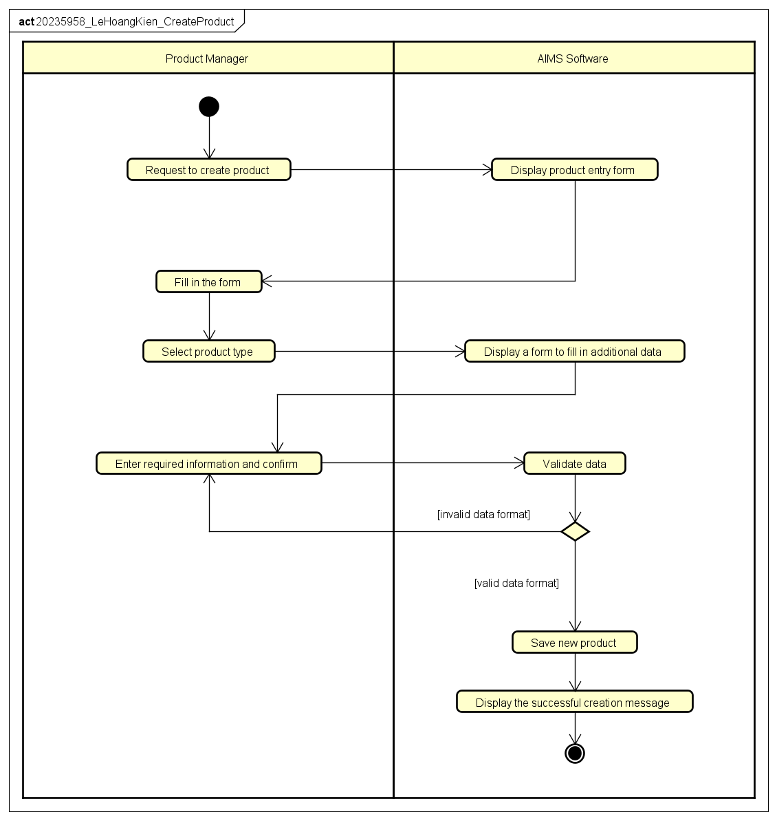
UC004 Create Product Activity Diagram

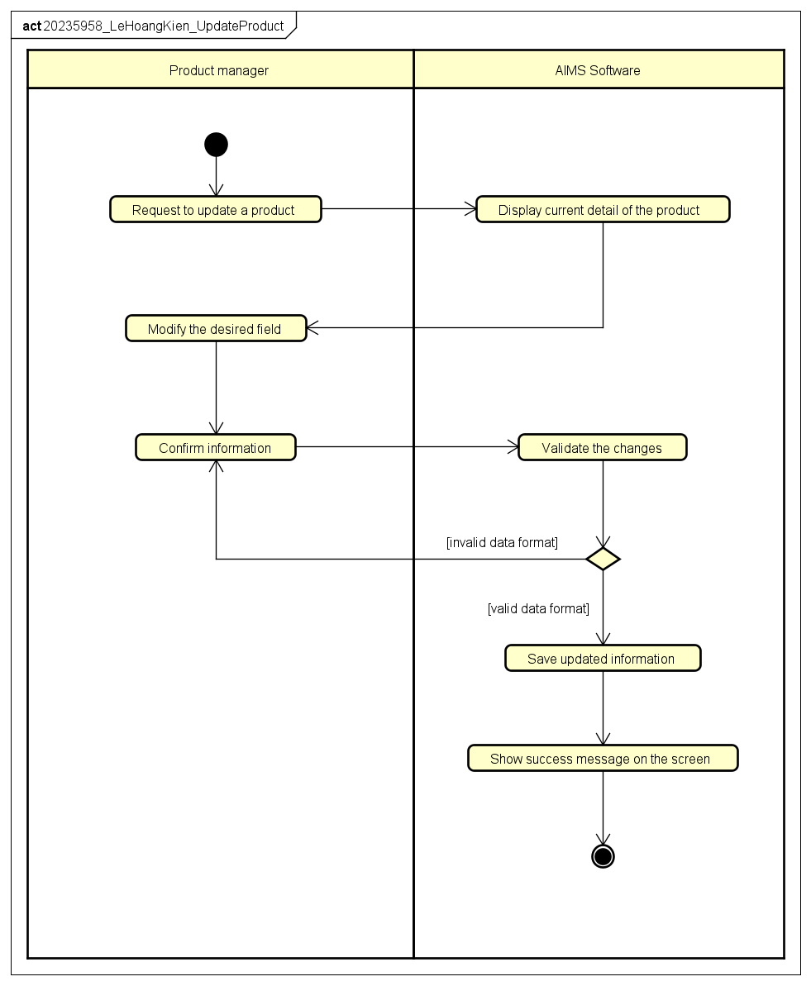
UC004 Update Product Activity Diagram
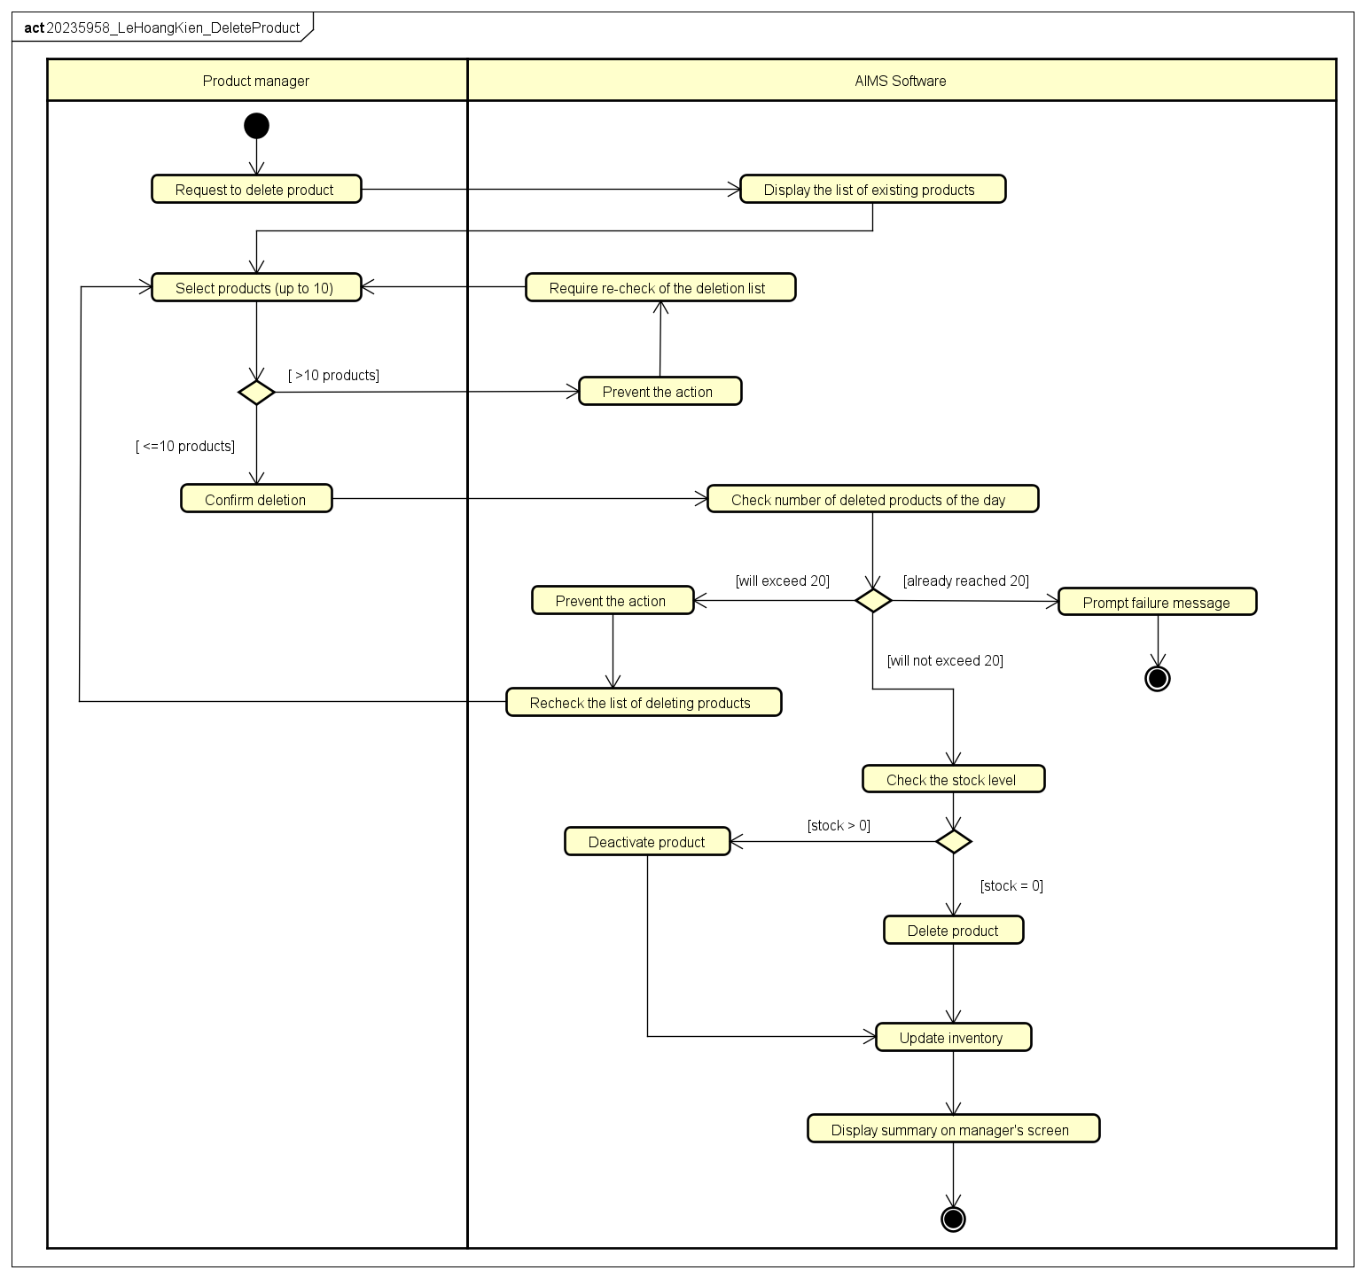
UC004 Delete Product Activity Diagram

Supplementary specification

Functionality
- The system shall log every sensitive administrative action and notify affected users. Each log captures the User ID of the performer, the timestamp, the type of operation, and a reference to the affected data.
- The system shall store the history of product creations, updates, deletions. The system shall allow Product Manager to query these histories through the system interface.
- The system shall securely hash every password so that Administrators cannot access plaintext passwords.
- The system shall validate all user inputs to ensure required fields are not empty and data matches expected formats.
- The system shall strictly apply the business rule that any current price modification must remain within the range of 30% to 150% of the product's original value.
- The system shall ensure that every product barcode is unique across the entire database.
- The system shall automatically calculate and append a 10% VAT to the current price of all media products.
- The system shall calculate shipping costs based on the product's physical attributes (weight, height, width, length) and the delivery destination.
- The system shall provide feedback (success messages, warning dialogs, or error alerts) for every user action.

Usability
- The system shall provide easy-to-use navigation to help users accomplish their tasks
- The system shall not require users to create an account, providing an easy way to browse and purchase products
- The system shall display product information in a clear and organized manner so that customers can quickly understand product characteristics such as title, category, price, and description

Reliability
- The system shall operate 24/7, providing its services at any time without interruption
- The system shall resume normal operations within a maximum of 1 hour after an incident
- The system shall maintain stable operation for at least 300 consecutive hours without failure

Performance
- The system shall support up to 1,000 customers without a significant drop in performance
- The system shall have a response time of 2 seconds under normal conditions or 5 seconds during peak hours

Supportability
- The system architecture shall be designed to allow easy addition of new media types, notification methods, and payment methods
- The system shall record system logs for important operations such as product updates, order processing, and user management activities.

Other requirements
- The system shall not allow the product manager to delete more than 20 products per day
- The system shall strictly apply a 10% VAT for all physical media items
- The system should allow additional payment methods to be integrated into the system in future versions

